CITY OF CANNON FALLS GOODHUE COUNTY, MINNESOTA

ORDINANCE NUMBER 386 SECOND SERIES

AN ORDINANCE OF THE CITY OF CANNON FALLS, MINNESOTA ANNEXING LAND LOCATED IN CANNON FALLS TOWNSHIP, GOODHUE COUNTY, MINNESOTA PURSUANT TO MINNESOTA STATUTES § 414.033, SUBDIVISION 2(3), PERMITTING ANNEXATION BY ORDINANCE

WHEREAS, a petition signed by all the property owners, requesting that property legally described on attached Exhibit A and depicted on attached Exhibit B be annexed to the City of Cannon Falls, Minnesota, was duly presented to the Council of the City of Cannon Falls on June 21, 2022; and

WHEREAS, said property is unincorporated and abuts the City of Cannon Falls on its northwest boundary; is less than 120 acres; is not presently served by public sewer facilities or public sewer facilities are not otherwise available; and

WHEREAS, said property is not located within a flood plain or shoreland area; and

WHEREAS, said property is currently residential and agricultural and annexation is requested to facilitate the extension of city services for the residential development of the property; and

WHEREAS, the City of Cannon Falls held a public hearing pursuant to Minnesota Statutes § 414.033, subd. 2b on August 2, 2022, following thirty (30) days written notice by certified mail to the Town of Cannon Falls and to all landowners within and contiguous to the area to be annexed; and

WHEREAS, provisions of Minnesota Statutes § 414.033, subd. 13 are not applicable in that there will be no change in the electric utility service provider resulting from the annexation of the territory to the municipality.

NOW, THEREFORE, THE CITY COUNCIL OF THE CITY OF CANNON FALLS HEREBY ORDAINS AS FOLLOWS:

- The City Council hereby determines that the property as hereinafter described abuts the city limits and is or is about to become urban or suburban in nature in that residential use is being proposed for said property the construction of which requires or will need city services, including public sewer facilities.

- None of the property is now included within the limits of any city, or in any area that has already been designated for orderly annexation pursuant to Minnesota Statutes § 414.0325.

- The corporate limits of the City of Cannon Falls, Minnesota, are hereby extended to include the following described property, said land abutting the City of Cannon Falls and being 120 acres or less in area, and is not presently served by public sewer facilities or public sewer facilities are not otherwise available, and the City having received a petition for annexation from all the property owners of the land, to wit: See attached Exhibit A (hereinafter, the “Annexation Property”).

The Annexation Property consists of a total of 53.86 acres, more or less. Copies of the corporate boundary map showing the Annexation Property and its relationship to the corporate boundaries of the City of Cannon Falls and all appropriate plat maps are attached hereto.

- That the population of the Annexation Property is 0.

- The City of Cannon Falls, pursuant to Minnesota Statutes § 414.036, that with respect to the property taxes payable on the area legally described herein, hereby annexed, shall make a cash payment to the Town of Cannon Falls in the amount of one year’s property taxes for the property to be annexed in the total amount of $798.20 (2022 taxes were $14.82 per acre on the entire 145.45 acres; 53.86 acres to be annexed). The payment shall be made in accordance with the following schedule:

  - In the first year following the year in which the City of
Cannon Falls could first levy on the annexed area, an amount equal to $399.10 and
  - In the second year, an amount equal to $399.10.

- That pursuant to Minnesota Statutes § 414.036 with respect to any special assessments assigned by the Town to the Annexation Property and any portion of debt incurred by the Town prior to the annexation and attributable to the Annexation Property, but for which no special assessments are outstanding, for the area legally described herein there are no special assessments or debt incurred by the Town on the subject are for which reimbursement is required.

- That pursuant to City Code § 152.448 the Annexation Property is presumed to be classified UR District. However, the City Council has made a determination that the appropriate classification for the Annexation Property is R-3 Medium Density Residential and that upon annexation the property shall be automatically classified as such without need for a separate amendment to rezone the property.

- That the City Clerk of the City of Cannon Falls is hereby authorized and directed to file a copy of this Ordinance with the Municipal Boundary Adjustment Unit of the Office of Administrative Hearings, the Minnesota Secretary of State, the Goodhue County Auditor, and the Cannon Falls Township Clerk.

- That this Ordinance shall be in full force and effect and final upon the date this Ordinance is approved by the Office of Administrative Hearings.

PASSED AND ADOPTED by the City Council of the City of Cannon Falls, Minnesota, this
day of , 2022.

John O. Althoff, Mayor
ATTEST:

Neil L. Jensen, City Administrator

Exhibit A

Legal Description of Property to be Annexed

That part of the Northeast Quarter of Section 7, Township 112 North, Range 17 West, Goodhue County, Minnesota, described as follows:

Beginning at the east quarter corner of said Section 7, thence on an assumed bearing of North 89 degrees 20 minutes 37 seconds West, along the south line of said Northeast Quarter and along the north line of PINE TREE RIDGE RE PLAT CITY OF CANNON FALLS, according to the recorded plat thereof, on file in the Goodhue County Recorder’s office, a distance of 1304.66 feet; thence North 00 degrees 18 minutes 13 seconds West, a distance of 106.0S feet; thence North 53 degrees 37 minutes 15 seconds West, a distance of 686.S2 feet; thence South 89 degrees 42 minutes 31 seconds West, a distance of 761.55 feet to the west line of said Northeast Quarter; thence North 00 degrees 17 minutes 23 seconds West, along the west line of said Northeast Quarter, a distance of 573.24 feet; thence North 65 degrees 15 minutes 57 seconds East, a distance of 1380.50 feet; thence South 89 degrees 38 minutes 30 seconds East, a distance of 282.40 feet; thence South 00 degrees 18 minutes 11 seconds West, a distance of 884.48 feet; thence South 89 degrees 38 minutes 30 seconds East, a distance of
665.90 feet; thence South 48 degrees 30 minutes 43 seconds East, a distance of 570.03 feet to the east line of said Northeast Quarter; thence South 00 degrees 18 minutes 11 seconds West, along the east line of said Northeast Quarter, a distance of 407.13 feet to the point of beginning.

EXCEPT:

That part of the Southeast Quarter of the Northeast Quarter which lies southeasterly of the centerline of Goodhue County Road Number 17, as now located and established.

Exhibit B

Map of Property to be Annexed

See Attached Map

CANNON FALLS, MINNESOTA

i ,
I
I

i
I
I
I
I
I

II'.
0

0

-;i,
,i-r
IJ)

""ii'i
u..
C:
0
§
u111
DAKOTA COUNTY GOODHUE COUNTY

><

:,-r
II'.
0z
:::,
0
?;
z
0
z
z
<u

8i 0
i

HOLIDAY AVE

- Randolph (7 miles)
..'. I :C
I§
C{ I 0
!
Q
I
I
I
I
I
I

I
I
I
I

COUNTY 17 BLVD

Cannon Valley Fairgrounds

.....

Cll
"ui.i.i
C:
g Welch Village ..
SklArea (13 miles) Red Wing (22 miles) -

..
annon River Boy Scout Camp (3.5 miles)
White Rock (9 miles) -

- Goodhue County Park Lake Byllesby (2 miles)

0
I_I.',.
:i=
0
0::

0

WILLOWTRL

VALLEY VIEW WAY

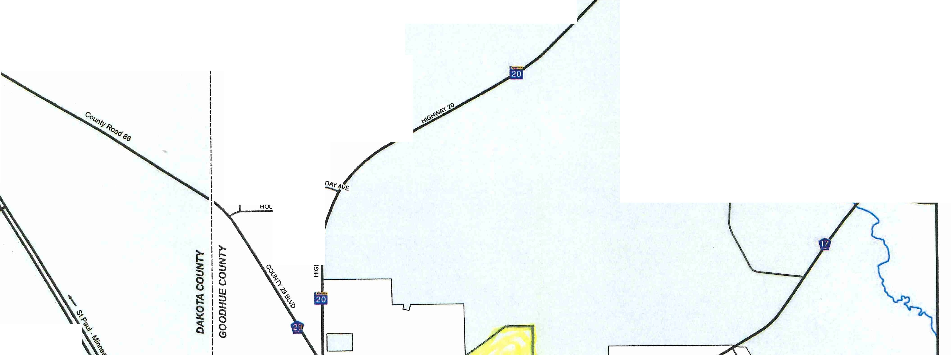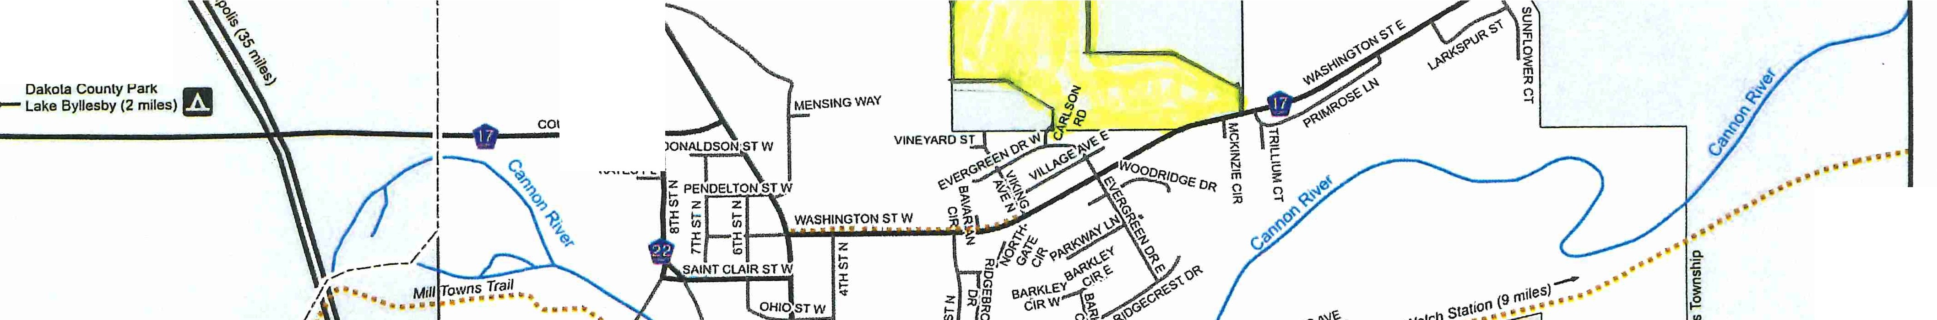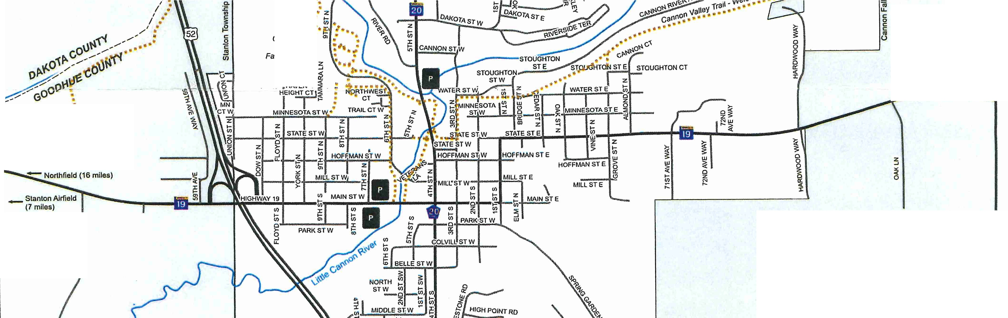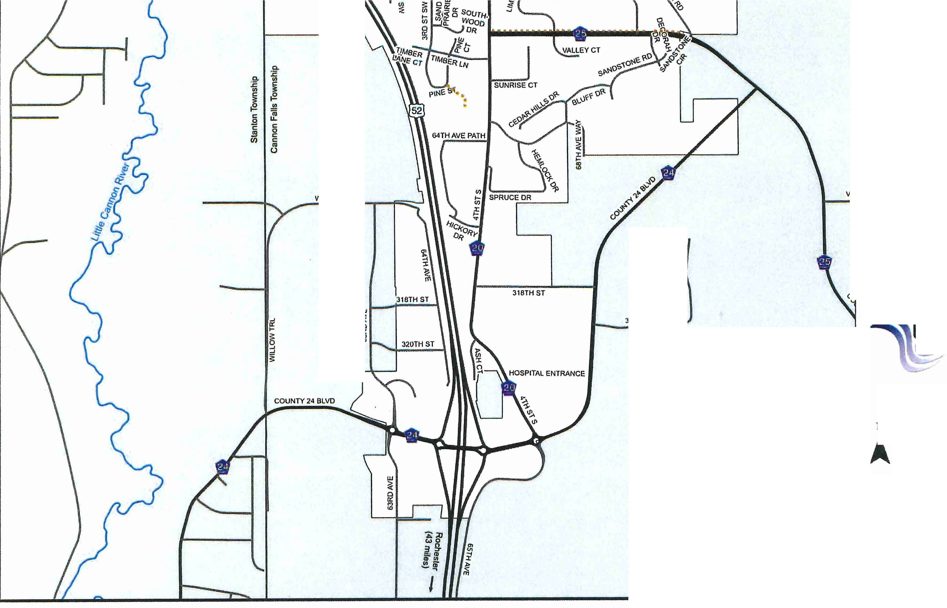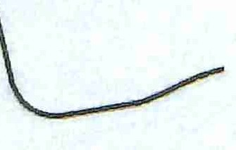
Cannon
'Clty□f Falls
www.cannonfallsmn.gov
N
Prepared for the City of Cannon Falls, MN
by Goodhue County GIS Office, January 2020

No Map Scale
DATA DISCLAIMER: Goodhue County assumes NO liability for the accuracy or completeness of
this map OR responsibility for any associated direct.
Indirect, or consequential damages that may result from its use or misuse. Goodhue County Copyright 2020

319TH CT WAY

