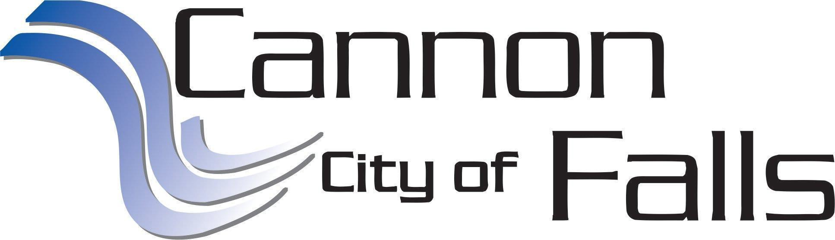

EDA MEETING AGENDA

**Thursday, March 2, 2023**

**3:30 p.m.**

***The EDA will meet in the City Hall Board Room***

1. **CALL TO ORDER**
2. **ROLL CALL: Cooreman, Dahl, Dombeck, Gesme, Montgomery**
3. **EDA BUSINESS**
   1. Approval of Agenda
   2. Approval of Minutes – February 2nd, 2023
   3. Financials *(available day of meeting)*
      1. Art Org Payment Update
      2. FEAST Event Donation – March 23rd
   4. 2022 EDA Annual Report
   5. Hardwood Estates Updates
      1. Ag/Rental
   6. 2023 Goal Planning Discussion *(continued)*
   7. Other Business
      1. Discover Cannon Falls Ad 2023
      2. American Vet Memorial media event– March 24th
      3. Next meeting: April 6th at 3:30 p.m.
4. **ADJOURN.**

Posted: February 27th, 2023

918 River Road| Cannon Falls, MN 55009 | 507-263-9312 | Fax: 507-263-5843